Sampath Lakkaraju (011818781)

Lab #2 Assignment - Google App Engine

CMPE 281-02 spring 2018.

Video link : <https://youtu.be/iggq-8im8-k>

Create an account at google cloud (<https://cloud.google.com/>)

Click on the console option at your right top corner.

On the menu go to app engine click on the dashboard option.

You will be prompted to start a new project and choose your first application and the language for the same.

To start an application in the google app engine I have selected a simple python application.

For making it simple I have used the code from the google sample app repository

(://github.com/GoogleCloudPlatform/python-docs-samples)

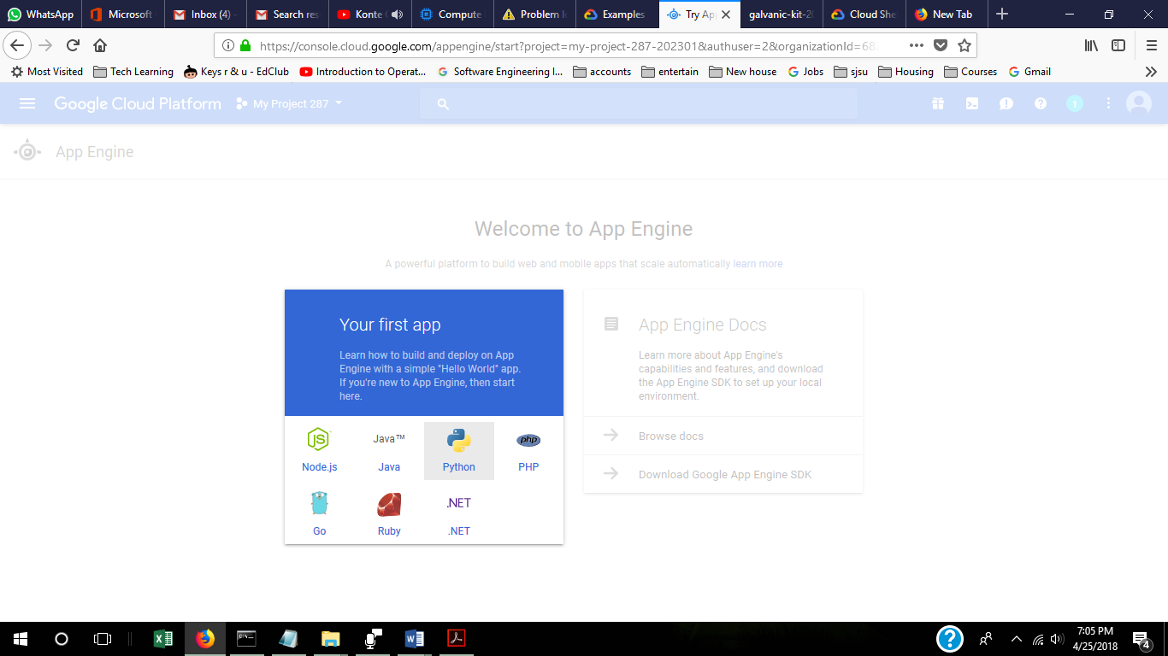

Select the region you would like to set up the instance.

Close the tour and click on the shell command on the top right corner “ **>_**”

This will open the shell command 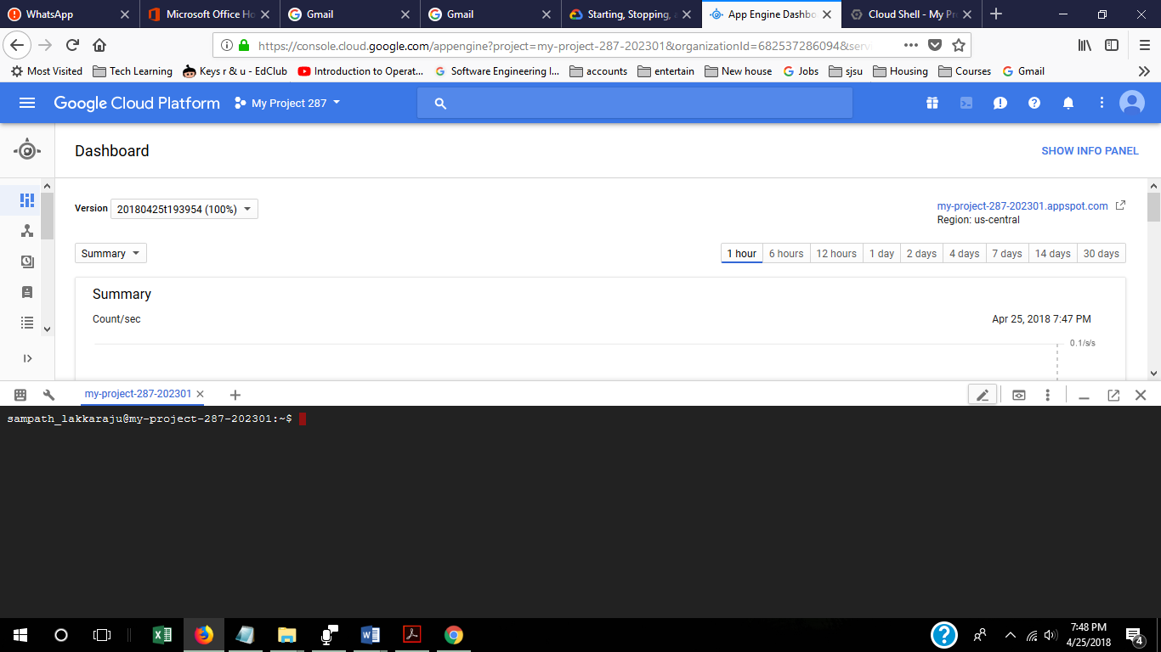

From the shell command line click on the cloud shell editor symbol

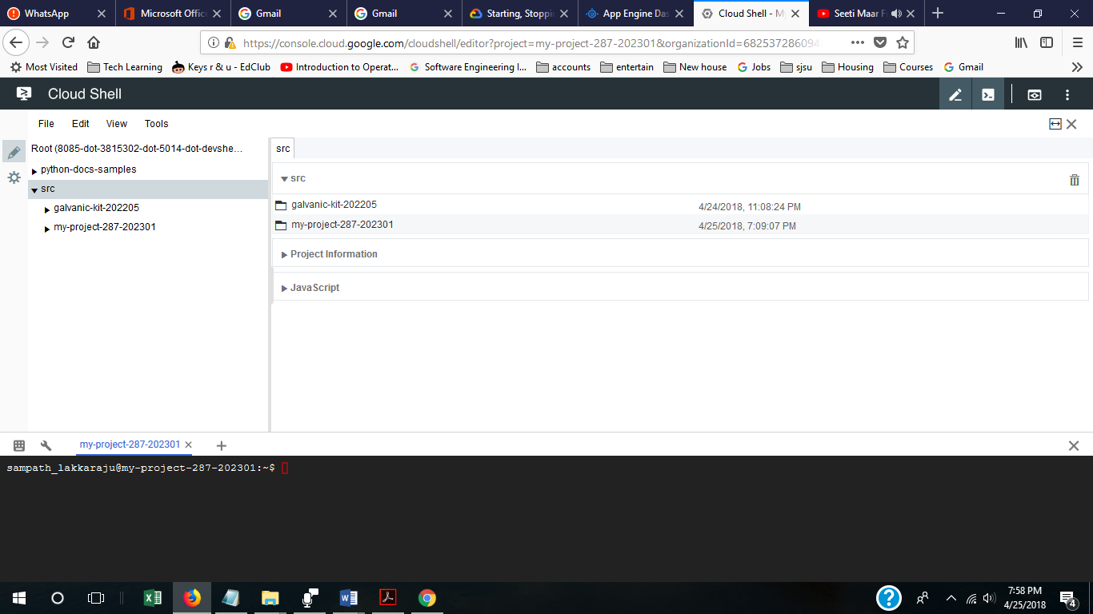

Once the editor opens clone the hello world code of google in to your instance using the following command

**git clone https://github.com/GoogleCloudPlatform/python-docs-samples**

Now go to the hello world folder in the cloned folder using the following:

**cd python-docs-samples/appengine/standard/hello_world**

There will be 3 files in the folder “app.yaml”, “main.py”, “main.pyc”. the main.py file contains the python code which is displayed in the application.

To deploy the application run the following command.

**gcloud app deploy app.yaml --project my-project-287-202301**

Type “y “and enter when prompted

Once the application deployed you will be prompted

Please run the command

**gcloud app browse**

The link to the application will be provided, click on the link in the shell and you will be directed towards the application in a new tab.

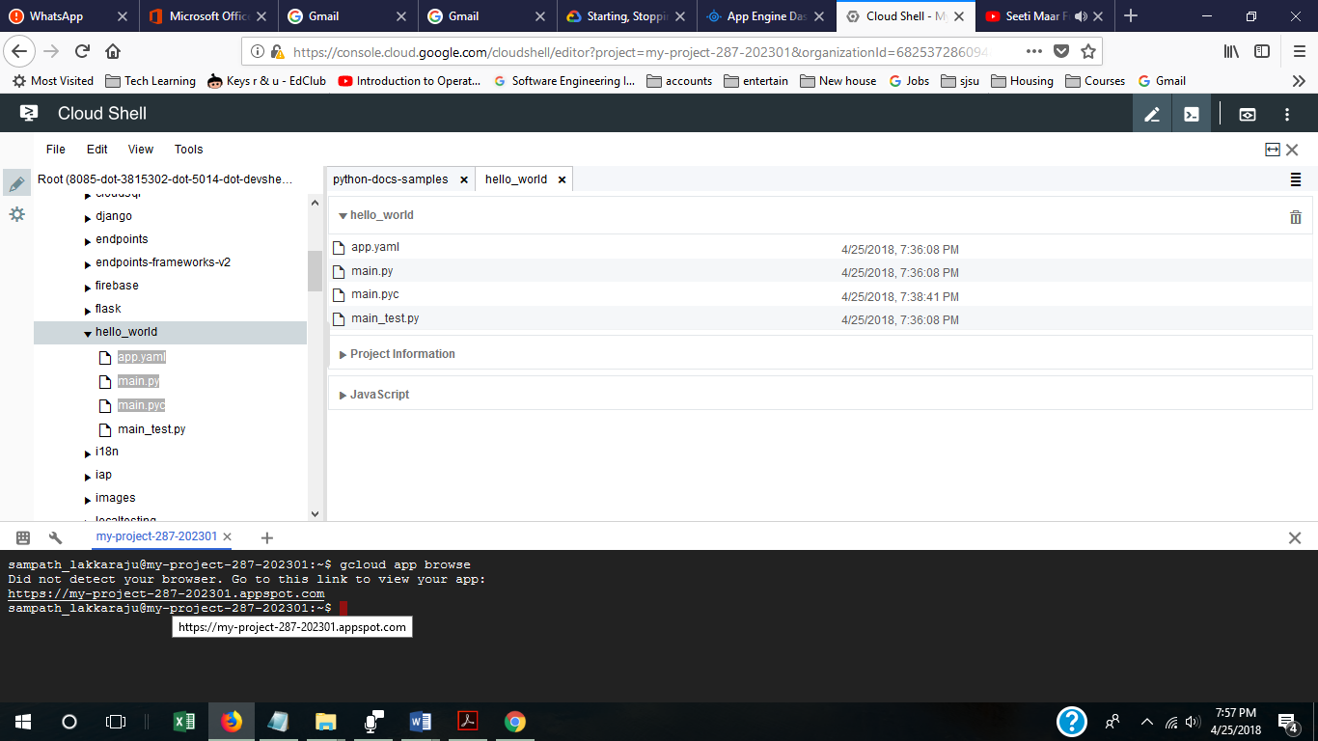

The hello world application is deployed and the message in the code is displayed in the link.

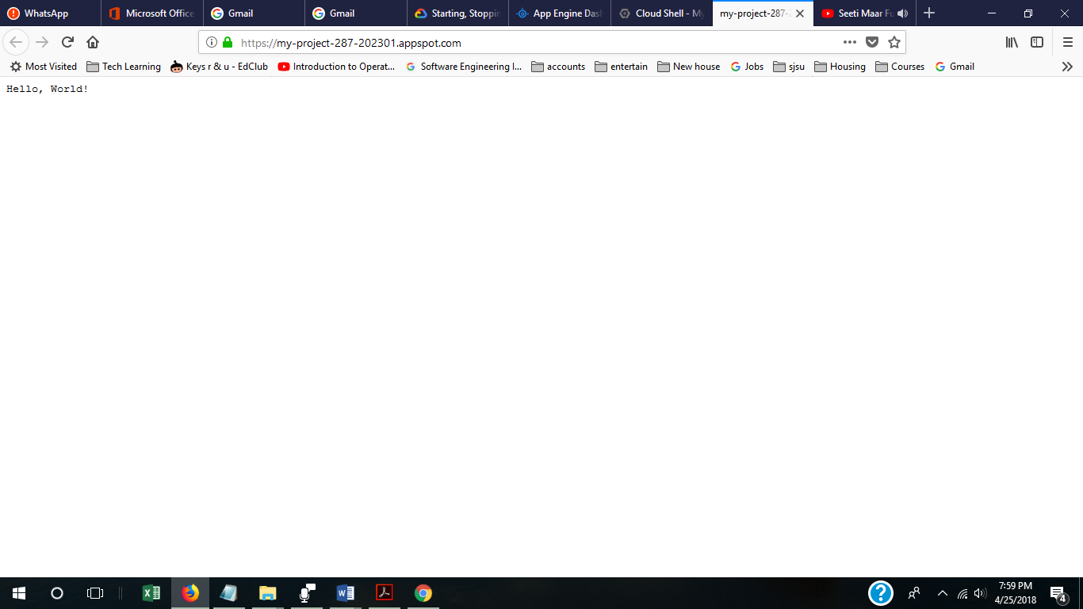

The code can be modified as per your requirement and you will be able to view the changes real time.

The same has been displayed in the video, which can be vied at the link: <https://youtu.be/iggq-8im8-k>

The statistics can be viewed from the Dashboard of the App Engine. The instance can be monitored form this dashboard or can modified from the IAM& admin option in the menu.

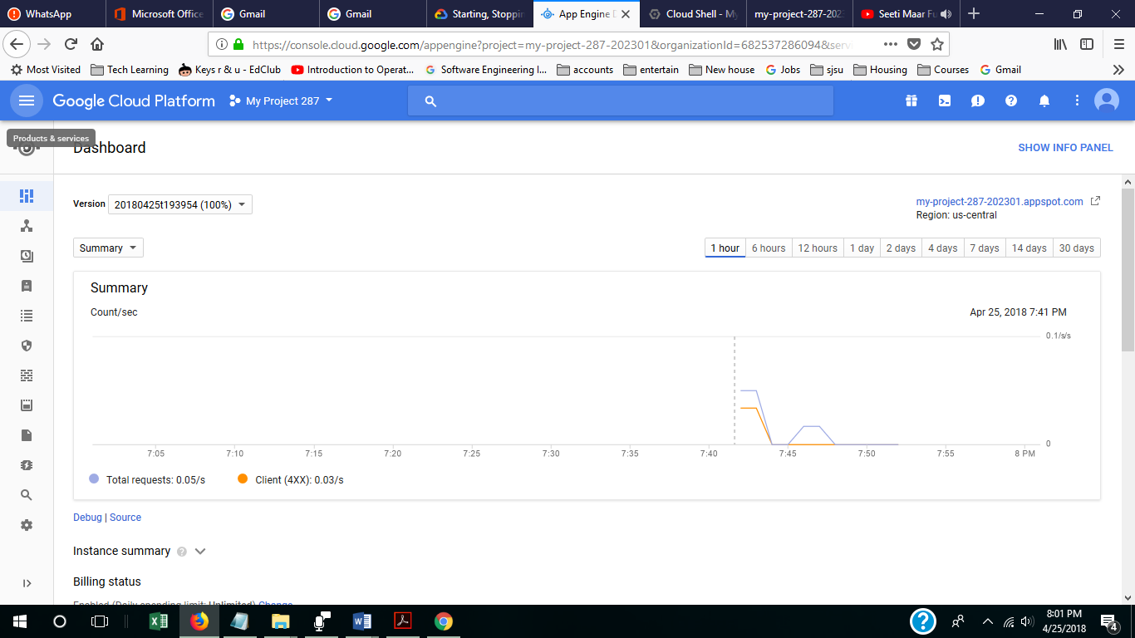

Thank you.